Singapore swallowing specialists

Home | Services | About us | CTAR & Research | New & updates | Contact us
Under home also add option to click for services  Updates of blog? | - - Swallowing difficulties (dysphagia)  - - 2nd opinion  - - Locum services  - - Training  - Consultation | The founder | About CTAR | Blog
 |  |  | Publications | Media
 |  |  |  | Gallery
Home

Welcome to Singapore Swallowing Specialists website!

Singapore Swallowing Specialists (SSS) is a network of healthcare professionals specialized in dysphagia care, as well as an informative website | blog on swallowing difficulties (dysphagia) management. SSS blog provides useful informations and tips on dysphagia management and it is followed by speech therapists and healthcare professionals from around the world.

SSS was initiated by the Mr Yoon Wai Lam (Founder of Speech Therapy Works, Singapore) in 2015. Mr Yoon has closed to 20 years of experience and he is a well known speech-swallowing therapist and dysphagia trainer in Singapore and in the region. He is the inventor of the award winning Chin Tuck Against Resistance (CTAR), a swallowing therapy exercise that is currently practiced worldwide.

Click to find out more about more about Mr Yoon Wai Lam

Mission

SSS has a wide network of multidisciplinary healthcare professionals with special interest in swallowing management from both public and private healthcare institution. Our missions:
- To provide comprehensive and cost effective assessment and treatment to individuals with swallowing difficulties.
- To provide support to other healthcare professionals dealing with swallowing difficulties in Singapore and in the region.
- To create more awareness on swallowing difficulties / dysphagia.

Services

Our vast network with the local hospitals (both public and private) and local specialists and healthcare professionals have allowed us to provide affordable and effective treatments.
Our Services include:
- Swallowing Management
    - Comprehensive assessment & treatment
- Second opinion
    - for patients or healthcare professionals
- Locum service
    - for hospitals / nursing homes / other healthcare institutions
- Training
    - for speech therapists and other healthcare professionals
- Consultancy services

Swallowing Management
Dysphagia refers to swallowing and/or feeding difficulties which affects the safety of food/fluids to travel from mouth to the stomach.
Dysphagia may be caused by the following common causes:-
- Stroke
- Neurodegenerative disease (Parkinson Disease, multiple sclerosis etc)
- Dementia
- Head and neck cancer
- Normal aging
- Other medical conditions that may affect any part of the swallowing mechanism
Assessment
Comprehensive swallowing assessment will be performed by our experienced speech therapists at the convenience of our clients in their home.
After the initial assessment, we will be able to understand the swallowing difficulties and this will allow us to make appropriate recommendations as below:
- feeding recommendation (oral or non-oral)
- oral feeding: diet or fluid modification.
- non-oral feeding: Tube feeding (NGT / PEG)
- caregiver trainings on:
  - understanding of the swallowing difficulties.
  - management plans (i.e. the need to be seen by other specialists or healthcare professionals)
  - training on how to prepare modified diet / fluids.
  - how to reduce the risks of chest infections.
-the need for further instrumental swallowing assessment (i.e. VFS / FEES)
Instrumental swallowing assessment
- Videofluoroscopy (VFS)
VFS (also known as modified barium swallow) is a moving x-ray examination of swallowing. During the examination, patient will be asked to chew and/or swallow food/liquids of different texture or consistencies. The videos obtained will allow detailed analysis of the swallowing functions for better treatment and management planning.

- Fiberoptic Endoscopic Evaluation for Swallowing (FEES)
FEES is a swallowing examination performed through the use of a small flexible telescope inserted through the nose by a trained speech therapist or an ENT specialist. During the examination, patient will be asked to chew and/or swallow food/liquids of different texture or consistencies. The videos obtained will allow detailed analysis of the swallowing functions for better treatment and management planning.
Treatment
Treatment will be specific in targeting the underlying cause/s of the swallowing problem to optimize recovery. Our treatment will include innovative approaches and new technologies such as:-
- Computerized swallowing therapy (sEMG Biofeedback Assisted Therapy)
- VitalStim Therapy
- Specific swallowing exercises/approaches targeting specific swallowing problems
- Prosthetic management

Second opinion for swallowing difficulties management to both patients and healthcare professionals.
With our vast experience and wide network in both public and private healthcare systems, we can provide second opinions on:
- diagnosis and the possible prognosis of the swallowing difficulties.
- recommendation on the suitable feeding option(s) – Oral or non-oral feeding.
- instrumental swallowing examination that is suitable to better understand the swallowing function.
- types of swallowing therapy that might be suitable: Traditional or specific swallowing therapy exercises, computerized swallowing therapy, electrical stimulations, K-taping etc.
- referral to other medical specialist(s) for further evaluation(s) or intervention(s)

Locum services for hospitals / nursing homes / other healthcare institutions
We have been providing locum services to public hospitals, private hospitals, rehabilitation hospitals and nursing homes since 2006.
We have gone the extra miles in serving our clients in our locum services. Beside seeing patients, we have assisted the local hospitals in:
- training speech therapists (dysphagia assessment & treatment, VFS, FEES, sEMG & etc)
- setting up new services such as FEES clinic, sEMG clinic.
- writing up treatment and service protocols.
- research
Our vast network has allowed us to explore joint services between institutions, the best possible treatment and management options for our patients.

Trainings

For Speech Therapists:
- The Importance of Physiological Understanding in Dysphagia Assessment and Treatment
- Dysphagia Assessment and Treatment for specific conditions (Strokes, Neurodegenerative Diseases, Head & Neck Cancers, etc)
- Advanced Dysphagia Management
- Surface Electromyography Biofeedback (sEMG) as an Adjunct to Dysphagia Therapy.
- How to apply clinical reasoning in dysphagia assessment and treatment?
- Videofluoroscopy (VFS): How to perform, interpret and plan management?
- Fiberoptic Endoscopic Examination for Swallowing (FEES): How to perform, interpret and plan management?

For Nurses / other Healthcare Professionals
- How to perform water swallow test?
- Understanding Dysphagia and It’s Management
- Swallowing Difficulties in People with Dementia
We are able conduct other trainings that are not listed above. Please contact us for further discussion.
Consultancy services
We provides the following consultancy services to hospitals, government agencies and nursing homes.

Some of the consultancy services that we have provided:
- Evaluating food or diet texture/consistencies according to IDDSI standard.
- Dysphagia treatment and management for junior speech therapists.
- Clinical audits for dysphagia cases.

About us

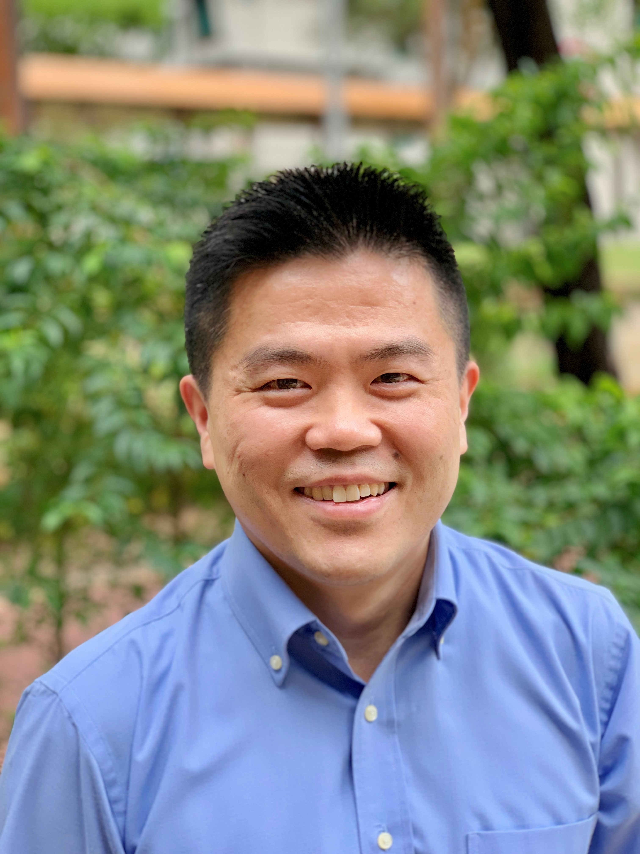

Yoon Wai Lam
Bachelor of Speech Sciences (Hons)
Fully Registered under AHPC
- Founder, Director of Speech Therapy Works LLP
- Founder of Singapore Swallowing Specialists Network and Informative Website
- Senior Principal Speech-Language Therapist
- Invited Lecturer, MSc (Speech and Language Pathology), National University of Singapore
- Examiner for the Speech-Language Therapy Qualifying Examination Board
- Inventor of the award winning Chin Tuck Against Resistance (CTAR) exercise
- Reviewer of the Dysphagia Journal

Wai Lam has close to 20 years of experience in adult speech, language and swallowing therapy. He is the inventor of the Chin Tuck Against Resistance (CTAR), a swallowing therapy exercise that is currently practiced worldwide. He has trained hundreds of speech therapists both locally and regionally. He is often consulted by speech therapists and other healthcare professionals for complex cases involving both speech and swallowing difficulties in Singapore and overseas.
He began his career in Singapore General Hospital (SGH) in year 2001. He was in charge of the dysphagia clinic, setting up of sEMG clinic, and Prosthetic Speech and Swallowing Clinic (PSSR) in collaboration with the National Dental Centre (NDC). In year 2006, he moved on to set up Speech Therapy Works to provide home therapy services and locum services to the local hospitals and nursing homes. He was also a part-time lecturer at the National University of Singapore (NUS), Masters in Speech-Language Pathology (SLP) programme from 2008-2018.
Wai Lam has developed training programmes and has been conducting trainings and workshops on dysarthria and dysphagia in Singapore and overseas. He continues to supervise and provide support to the speech therapists in local hospitals and from abroad. He has been actively supporting the development of dysphagia management in Malaysia. In 2019, he was invited as a co-trainer at the distinguished Langmore Foundation FEES Course & Post Laryngectomy Rehabilitation Course at Tata Memorial Hospital, Mumbai, India.
Wai Lam’s research papers has been presented at local and international conferences and published in international journals. His research on CTAR exercise has won the first price poster presentation at the Dysphagia Research Society at Seattle, USA in 2013. Wai Lam’s CTAR research papers have been widely cited in international journal papers and text books (ResearchGate March 2020: ~ 80 citations). Wai Lam is also a reviewer of the International Dysphagia Journal.
Wai Lam has developed various therapy protocol & therapy tools. His dysphagia therapy protocols for brainstem stroke, late effect from radiotherapy for nasopharyngeal cancer or head & neck cancer, and swallowing difficulties due to anterior cervical osteophytes have helped many patients to improve their swallowing functions. In 2018, he has successfully developed a smart swallowing device prototype in collaboration with the Singapore University of Technology and Design (SUTD). Research and development are ongoing.
Certification in:
- Videofluoroscopy (VFS)
- Fiberoptic Endoscopic Examination for Swallowing (FEES)
- Surface Electromyography Biofeedback (sEMG)
- Vitalstim Therapy
- McNeill Dysphagia Therapy Program (MDTP)
- Tracheostomy Management
- K-Taping® Speech and Language Therapy
- Lee Silvermann Voice Therapy (LSVT)
- Lessac-Madsen Resonant Voice Therapy (LMRVT)

Languages:
- English
- Mandarin
- Cantonese
- Hokkien
- Malay
- Bahasa Indonesia

Publications:

https://salts.org.sg/research-bites/an-interview-with-mr-woon-wai-lam/

Research

- Jose, R., Rendom, J., Yoon, W.L., Abillar, L., Low, P.S., Su, A.Q., (2019 September). New Practices in Thickener Mixing for Effective Care. Poster session presented at International Forum on Quality and Safety in Healthcare, Taipei
  - Awarded:
    - Agency for Intergrated Care (AIC) Quality Improvement Award (2018)
    - St Luke’s Hospital Clinical Quality Improvement Merit Award (2017)

- Yoon, W.L, Ng, W.T., Liow, S. (2017 March) Swallow with Chin Tuck Against Resistance (S-CTAR): New Task-Specific Swallowing Exercise for Training Submental Muscles. Poster session presented at the 25th Annual Meeting of the Dysphagia Research Society, Portland, Oregon, USA

- Sze, W. P., Yoon, W. L., Escoffier, N., & Rickard Liow, S. J. (2016). Evaluating the Training Effects of Two Swallowing Rehabilitation Therapies Using Surface Electromyography-Chin Tuck Against Resistance (CTAR) Exercise and the Shaker Exercise. Dysphagia, 31(2), 195–205. http://doi.org/10.1007/s00455-015-9678-2

- Kwan, K. M. R., Young, S., Yoon, W. L., (2016) Effects of Nasogastric Tube on Swallowing Function in Patients with Dysphagia Following Stroke. Poster session presented at the National University of Singapore, MSc(Speech & Language Pathology) Student Research Symposium (2016)

- Koh, K.T., Yoon. W.L. Young, S., (2014) Tongue Pressure and Endurance in Adults Using the Iowa Oral Performance Instrument. Poster session presented at the National University of Singapore, MSc(Speech & Language Pathology) Student Research Symposium (2014)

- Yoon, W.L., Khoo, J., & Liow, S. (2014). Chin tuck against resistance (CTAR): new method for enhancing suprahyoid muscle activity using a Shaker-type exercise. Dysphagia. Retrieved from http://link.springer.com/article/10.1007/s00455-013-9502-9
  - Awarded:
- 1st Place Scientific Abstract: Poster Presentation at the 21st Annual Meeting of the Dysphagia Research Society (March 2013) om Seattle, Washington, USA

- Yang, Y., Leow, L., Yoon, W.L., Liow, S., & Chua, K. (2012). Relationship Between Age and Drinking Instructions on the Modification of Drinking Behavior. Dysphagia. Retrieved from http://link.springer.com/article/10.1007/s00455-011-9355-z

- Yoon, W.L., Lau, P.C., Low, A.W., Chua, H.L., Lim, P.C. (2008 March) The Effect of Head Rotation on Patients with Bilateral Pharyngeal Weakness Following Radiation to the Neck Poster session presented at the 16th Annual Meeting of The Dysphagia Research Society, Charleston, South Carolina, USA

Courses Conducted

- Workshops on FEES, sEMG biofeedback and CTAR at the Inaugural Congress of the Asia Pacific Laryngology Association (APLA) | 8th International Annual Conference of Laryngology & Voice Association, Singapore (1 - 3 November 2019)
- Dysphagia Assessment and Treatment Workshops and FEES interpretation Workshop organized by SI Speech Therapy, Kuala Lumpur Malaysia (2016, 2017, 2018)
- NPC Support Group Talk on "Speech and Swallowing after Radiotherapy" (2014, 2015, 2018, 2019)
- Videofluoroscopy Interpretation Made Easy, Organized by SHAS (23 April 2015)
- Surface Electromyography (sEMG) Biofeedback as an Adjunct in Dysphagia Therapy, Organized by Speech Pathology Department, Hospital Universiti Kebangsaan Malaysia (21June2014)
- The Use of Videofluoroscopy in the Management of Complex Dysphagia Cases for SHAS Focus Group (Jan 2014)
- “Swallowing Disorders in Adults” for Speech Therapy Week 2011 Organized by SHAS at Ministry of Information, Communication and the Arts Building (2011)
- “Dysphagia Management & Introduction to Speech Therapy Services in Singapore” at FPSC 42: Integrated Eldercare Course organized by College of Family Physicians Singapore (2011)
- Medical Office Cource on Dysphagia Assessment and Management by Department of Geriatric Medicine, Khoo Teck Puat Hospital (2010)
- Understanding the Possible Side Effects of Radiotherapy on Speech, Swallowing and Voice. “What Can Be Done When It Occurs” for NPC Support Group, National Cancer Centre (May 2010)
- Workshop on Digital Swallowing Workstation and Fiberoptic Endoscopic Examination of Swallowing Organized by Department of Otolaryngology, University of Malaya, Malaysia (Dec 2009)
- Dentist Course on Speech and Swallowing Management Organized by National Dental Centre (2005)
- Medical Officer Course on Dysphagia, Dysphasia, and Dysarthria Assessment and Management Organized by Department of Rehabilitation, Singapore General Hospital (2002 and 2003)
- Medical Nursing Course for Registered Nursing Staff on Dysphagia, Dysphasia, and Dysarthria Management Organized by Department of Nursing Administration, Singapore General Hospital (2002)

Chin Tuck Against Resistance (CTAR) Swallowing Exercise

Chin Tuck Against Resistance (CTAR) is a swallowing exercise created by Mr Yoon Wai Lam in Singapore.

CTAR became one of the most popular swallowing exercise that is widely practiced worldwide since its introduction in 2013. In March 2013, our first scientific poster on CTAR was presented at the Dysphagia Research Society Meeting at Seattle, Washington, USA. Little did we expect that CTAR actually drew so much interest at the DRS meeting and was also awarded first place for the Scientific Abstract Poster. Chin Tuck Against Resistance (CTAR) is the top 10 most downloaded article from the Dysphagia Journal in 2014. To date (April 2020), our CTAR research publications have more than 80 citations in international journal papers and text books.
CTAR is a swallowing muscles strengthening exercise specifically targeting the suprahyoid muscles. CTAR is usually used in cases with decreased upper esophageal opening and incomplete epiglottic retroflexion secondary to reduced hyolaryngeal excursion. The effectiveness of CTAR in rehabilitating dysphagia has been reported in many researches (Kim et al., 2019; Park et al., 2019; Park et al., 2018; Gao et al., 2017 and etc.).
Swallow with Chin Tuck Against Resistance (S-CTAR)
Wai Lam created S-CTAR in 2015, a more task-specific swallowing strengthening exercise. In 2017, He presented S-CTAR research at the 25th Annual Meeting of the Dysphagia Research Society, Portland, Oregon, USA in 2017.

How to perform CTAR?

- Sit up straight. Broaden your shoulders
- Chin tuck down (more than 20 degrees) against resistance
- Resistance to be provided by using:
  - Rubber ball
  - Palm (pushing upwards) – self or assisted by others.
  - Neckline slimmer
- Ensure that the chin tuck is maintained at least 20 degrees or more during isometric

- Suggested therapy regime is the same as Shaker’s exercise (Shaker, 1997)
  - Isometric:
    - Sustain chin tuck down against resistance for 60 seconds. Rest for 1-2 minutes.
    - Perform 3 cycles
  - Isokinetic:
    - Repeat chin tuck down against resistance and chin up x 30 times. Rest for 1-2 minutes.
    - Perform 2 cycles

  - Perform 2-3 sets daily

Clinician to adjust frequency and intensity accordingly to patient’s ability

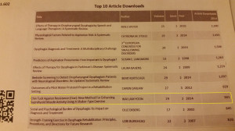
CTAR is top 10 most downloaded article in Dysphagia 2014
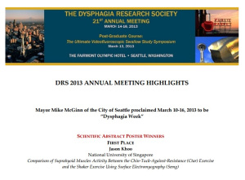

CTAR was awarded first place in Scientific Abstract Poster at DRS 2013[/caption]
Some facts about CTAR
Here is how it all begins….
The hunt for stretch ball was started in the year 2002 when Wai Lam was still a junior SLP at Singapore General Hospital. He drew the inspiration from his geriatric patients who kept complaining that the Shaker's exercise are too strenuous and they declined to perform it. After some thought, he came out with the idea of performing the chin tuck in a sitting position and conveniently use one of the stretch ball belongs to one of the patient and placed it under the patient’s chin as resistance. The geriatric patient was more willing to perform it and complaint of soreness felt at the chin area (Suprahyoid area) - that's the sign of muscle fatigue! So Wai Lam started to hunt for stretch balls on the very same night, bought at least 10 pieces. But he did not take into consideration the variation in neck length. The stretch ball was too small and hard for those with longer neck to hold it in between their chin and chest. A bigger ball was used (~10cm) and it seems to fit in nicely for most patients.

